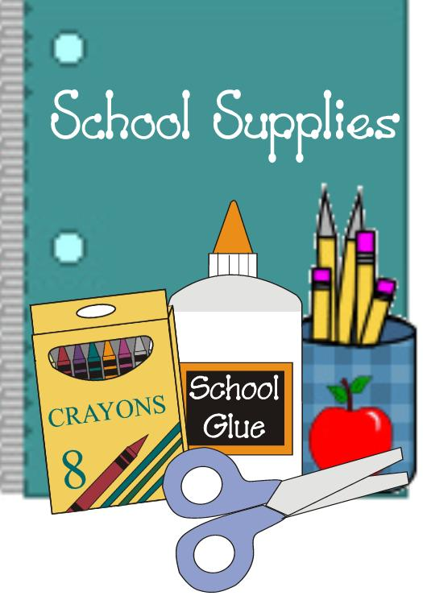
Fourth Grade Supply List
2023-2024

7 marble composition notebooks
6 pocket folders (black, orange, green, yellow, white, purple)
1 pencil case
48 Pre-sharpened Ticonderoga #2 pencils
1 box of sharpened colored pencils
10 low-odor dry erase markers (chisel tip)
1 eraser for dry erase board
1 black Sharpie
3 highlighters
6 large glue sticks
1 pair of scissors
1 pencil sharpener
1 packet of Post-Its (any color)
1 Slide Locking Report Cover
1 pair of inexpensive headphones
1 box of ziploc bags - gallon size
Spanish
2 Glue Sticks

