2nd GRADE SUPPLY LIST
2023-2024
2 boxes | Crayons--24 count
1 package | Washable Markers--8 count
2 packages | Thin Washable Markers--8 count
1 package | Sharpened Colored Pencils
1 | Yellow HIghlighter
12 | Glue Sticks
1 pair | Children’s Scissors
2 dozen | #2 Sharpened Pencils with erasers--not mechanical
1 package | Expo Dry Erase Markers--4 count
1 roll | Scotch Tape
1 box | Cap Erasers
1 | 1 Subject, Spiral Bound Notebook with Black Cover
1  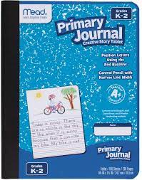 | Mead composition Primary Journal K-2 Creative Story Tablet (with blank box at the top and lines on the bottom of the page)--May be found at Target
1  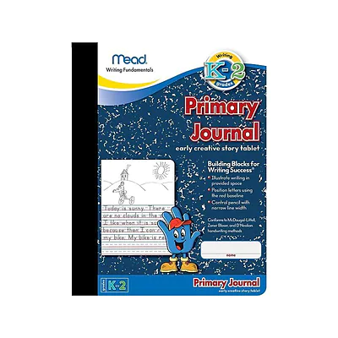 | Mead Primary Composition Early Creative Writing Tablet-Primary Writing Stage 3 K-2
1 package | Post-It Notes 3 in.x 3 in.
9 | Plastic Folders: 5 Star with bottom pockets (hard shell type)  1 each of the following colors: red, white, purple, and green  3 Blue, 2 Yellow (1 yellow for Spanish)
1 | Clear Shoe Box with Lid
1 | Work Box 8 in.x5 in.
1 | 2.5 Gallon Size ZipLock Bag for Reader’s Workshop
1 | Hand Held Personal Sharpener
1 | 12 in. ruler

